**{{ Site Name }}**

Chiller {{Chiller Number}}

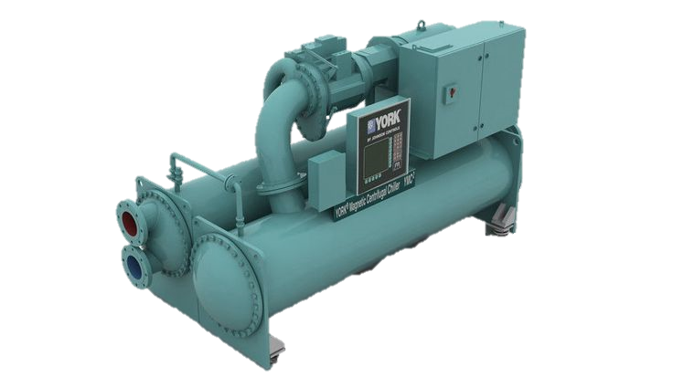

|  |  |
| --- | --- |
| **Chiller Spesification** | |
| Chiller Model |  |
| Serial Number |  |
| Refrigerant |  |
| Net WT |  |
| Compressor Model |  |
| Gear Model |  |

Chiller Performance Summary

{{Chart}}

**Note**

{{Chart}}

**Note**